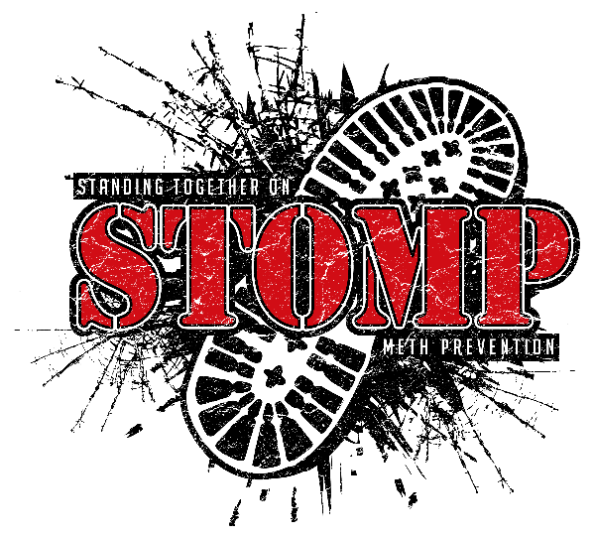
Jack County Community Resources
Addiction/Substance Abuse
MHMR- (940)549-4896, johnstonc@helenfarabee.org
1720 4th St
Graham, TX 76450
Recovery Resource Council
(817)332-6329
SAMHSA National Helpline
(800)662-4357
Red River State Hospital
(940)322-3171
Addiction Recovery Ministries (ARMS)
(940)325-7466
Jack County STOMP
505 W. Belknap St
Jacksboro, Tx
(940)507-5110
www.jackcountystomp.org
Hope Center Ministries (State Funded)
(866)396-4673
www.hopecm.com
Freedom House (Denton)(State Funded)
(940) 565-5990
Serenity House (Abilene)(Medicaid, financing options)
(325)673-6489
A New Entry (Austin) (State Funded)
(512)464-1250 ex.104
Cenikor Foundation (Waco) (State Funded)
(254)262-3528
Integral Care (Houston) (State Funded)
(512)472-4357
Teen Challenge (Azel, TX) (Free)
(866)913-4181
Strong Tower (Hitchcock, TX)
(855)823-4546
www.urmystrongtower.com
Rise Home (Abilene) (State Funded)
Men-(325)232-8544
Women-(325)704-1265
www.risehome.org

Shelters/Housing/Utility Assistance
Graham Area Crisis Center for Battered Women (Harry’s House)
(940)549-6002
Catholic Charities
(940)761-6151
Medical, Dental, Immigration Assistance, Veterans Services, Education Navigation, Domestic Violence Support, Rental Assistance
Shelter For Women and Children at Wichita Falls Faith Mission Faith Refuge
710 E. Hatton Rd.
Wichita Falls, TX 76302
(940) 322-4673
Wise Hope Shelter & Crisis Center
200 N. Church St
Jacksboro, TX 76458
(940)507-5025
(940)626-4855
www.wisehope.org
Teen Emergency Shelter at Children's Aid Society of West Texas
1101 30th Street
Wichita Falls, TX 76302
Children’s Home
940-322-3141
Teen Emergency Shelter
940-322-7671
First Step Domestic Violence Shelter/ Sexual Assault Assistance
PO Box 4085
Wichita Falls, TX
(800)658-2683
Outreach Office
(940)723-7799
www.firststep.org
The Salvation Army of Wichita Falls Shelter and Social Services
403 7th Street
Wichita Falls, TX 76307
(940) 322-9822

Rolling Plains Management Corp.
(childcare, child care assistance, child nutrition, weatherization assistance, Rural Public & Medical Transportation, Emergency Assistance, Head Start, Tenant Based Rental Assistance, Energy Assistance)
(800) 633-0852
118 North 1st Street PO Box 490
Crowell, Tx
www.rollingplains.org
Jacksboro Parish (Utility Assistance)
-1 time in 6 months up to $75 must pass background check.
(940)567-3735
115 N Knox St.
Jacksboro, TX
First United Methodist Church (Pastor helping hands)
-must fill out application
(940)567-6341
406 N Main St
Jacksboro, TX
The Light Church (utility assistance)
321 N 2nd St
Jacksboro, TX
(940)229-9273
Veteran Supportive Housing
(877)424-3838
Housing Choice Voucher Program
(940)761-6893
Cornerstone Community Agency
(325)625-4167
www.cornerstonecaa.org/utility-assistance
Food Assistance/Pantry
Graham Health and Human Services Food Stamp Office
1202 Packing House Road
Graham, Tx
(940)549-1371
www.yourtexasbenefits.com
The Light Church
321 N 2nd St
Jacksboro, Tx
3rd Monday of each month, need 2 proof of residency.
Produce truck comes first Wednesday of each month.
Graham Crisis Center
601 Indiana St
Graham, Tx
(940)549-6002
Tuesday 10-12 & 1-3
Thursday 10-12 & 1-3
Meals on Wheels
(940)567-2607
Wise Area Relief Mission (WARM)
300 North Trinity Street
Decatur, Tx
(940)626-4676
Tuesday 9-2
Wednesday 12-6
Thursday 9-2
Friday 9-2
North Texas Pantry
903 Tyler St
Wichita Falls, Tx
Email: info@ntxpantry.org
Monday 9:30-11am
Tuesday 9:30-11am
Wednesday 8-5
Thursday 9:30-11
Friday 8-5
Food Pantry Churches of St. Mary & St. Boniface
101 Church St
(940)423-6687
Email: windscot@comcell.net
Thursday 9-11am
WIC (Wednesdays)
212 N Church St
Jacksboro, Tx
(940)567-2601
Clothing Assistance
Clothes Closet (Open on Wednesdays)
681 US HWY 380 W
Jacksboro, Tx
(940)567-2225
Child Welfare Board (Emergency Resources for Jack County Children)
P.O. Box 251
Jacksboro, Tx
(940)567-2241
The Nifty Thrifty (Graham Crisis Center)
Mon-Sat 10-3
(940) 549-0411
601 Indiana Street
Graham, Tx
Noah’s Ark Thrift Store
109 SE 9th Ave
Mineral Wells, TX
(940)325-4404
Counseling Services
Wise Hope (Family Abuse, Sexual Assault, Services are free)
200 North Church St
(940)507-5025
Safe Harbor Christian Counseling (Fees are on sliding scale, counseling teens, divorce recovery, stress management, anxiety, depression, ADHD, grief, anger management, panic attacks etc)
321 N. 2nd St
Jacksboro, Tx
(682)615-2293
Affirming Texas Families (Services are free, counseling for individuals, adults, children, family, victim, parenting classes)
(855)239-2837
Counseling Center of Decatur (Reduced Fees is an option)
www.ccdcouseling.com
2304 South FM 51
Decatur, Tx
(940)627-5238
Graham Psychological Associates (Insurance Accepted)
www.grahampsychological.com
(940)549-2259
STARRY Counseling (Services are free)
www.starry.org
(940)386-9546
Crisis hotline: (800)440-9789
Hospice of Wichita Falls (Services are free, grief counseling family, children, teens, adults)
www.howf.org/grief-support
(940)691-0982
Rose Street Mental Health Care (Individual therapy for children-seniors, Psychiatric Evaluation, Addiction evaluation and treatment, does accept Medicaid, Medicare, insurance)
www.rosestreet.org
(888)723-7673
(940)322-2372
Taft Counseling Center (Does accept Medicare, Medicaid, all insurance, private pay is available on sliding scale)
4722 Taft Blvd St#2
Wichita Falls, Tx
(940)691-1899
Private Practice Counselors:
Brittany Norville, MS (Fees on a sliding scale)
The Light Church
(682)615-2293
Laura Taylor (Fee is required)
(940)532-1129
Transportation
Sharp Transportation
(800)633-0852
First Baptist Church (has a group to give rides to get groceries, doctors’ visits, run errands etc)
200 N. Knox St
Jacksboro, Tx
(940)567-3741
Medicaid Number for Trips
(877)633-8747
Health
Faith Community Hospital (Does have indigent program for qualifying individuals)
215 Chisholm Trail
Jacksboro, Tx
(940)567-6633
Faith Rural Health Clinic
215 Chisholm Trail
Jacksboro, Tx
(940)567-5528
Jacksboro Clinic
217 W. Belknap St
Jacksboro, Tx
(940)567-8114
Swan Family Wellness Center (Gym & Physical Therapy)
217 Chisholm Trail
Jacksboro, Tx
(940)216-2379
Jacksboro Pregnancy Resource Center (pregnancy options, adoption, STD’s, parenting, abortion recovery, assistance with diapers, formula etc)
215 Chisholm Trail
Jacksboro, Tx
(940)507-0226
Department of Health and Human Services
(940)549-1371
City Drug Store (has a free vitamin program)
104 E. Belknap St
Jacksboro, Tx
(940)567-5576
Medicaid/CHIP
(800)252-8263
www.yourtexasbenefits.com
Catholic Charities
(940)761-6151
Medical, Dental, Immigration Assistance, Veterans Services, Education Navigation, Domestic Violence Support, Rental Assistance
Senior Services
Faith Community Nursing Home
211 E Jasper St
Jacksboro, Tx
(940)567-2686
Greystone Assisted Living
1116 Hwy 148 #37
Jacksboro, Tx
(800) 385-2527
Concerned Citizens
400 E. Pine St
Jacksboro, Tx
(940)567-2607
Medicare Hotline
(800)633-4227
Social Security Administration
(800)772-1213
Veteran Affairs
(877)927-8387
Area Agency on Aging
(800)272-3921
(940)322-5281
Legal Services
iDocket (Provides judicial information on the internet & eFiling service provider)
www.idocket.com
Jack County Clerks’ Office
100 N Main, Suite 208
Jacksboro, Tx
(940)567-2111
Jack County District Clerk
100 N Main, Suite 310
Jacksboro, Tx
(940)567-2141
Legal Aid (Free Legal Help)
(817)594-6332
Employment Services
Texas Workforce Commission
www.twc.texas.gov/jobseekers/job-search
(888)548-WORK(9675)
TRC/DARS
www.twc.texas.gov/jobseekers/vocational-rehabilitation-services
(800)628-5115
Rolling Plains Management Corporation
www.applicantpro.com/openings/rollingplains/jobs
(800)232-8329
US Department of Labor
www.dol.gov/agencies/eta/employment-services
Child Care/Advocacy
Child Advocacy
www.cacnorthtexas.org
(972)317-2818
development@cacnorthtexas,org
Head Start (Free, reduced)
(940)205-5412
(940)205-5411
www.cornerstonecaa.org
Child Abuse Reporting
(800)252-5400
Child Protective Services
(940)549-2396
Mother’s Day Out (Tuesdays and Thursdays)
The Parish
(940)567-3735
115 N Knox St.
Jacksboro, TX
Jacksboro Child Care Center
750 W. Belknap St.
(940)567-7203
www.jacksboroisd.net/page/child-care
Learn and Play
420 N Sixth St
Jacksboro, Tx
(940)507-3113
Housing
Rental Property Owners
Crombie Properties
(940)507-2356
Katrina Ross
(940)507-0587
Tom Sessions
(940)567-1281
Charlie Hayhurst
(940)229-8172
Bigger Boat Properties, LLC
Fore Sail Properties, LLC
(817)307-0204
Patti Zuber
(940)567-3305
(940)567-1350
Stonebridge Apartment
(817)703-3420
Dori Taylor
(940)393-6474
James Cope
(682)225-4247
Circle H Properties
(940)452-3223
Government Assistance Apartments
Bent Tree Apartment
323 N 9th St
Jacksboro, Tx
(940)567-5316
Mesquite Trail Apartments
119 S. 5th Street
Jacksboro, Tx
(940)567-3304
Pecan Hill Apartments
400 E. Dempsey St
Bryson, Tx
(940)392-2166
Jacksboro Emergency Departments
Jacksboro Fire Department
128 E. College St
Jacksboro, Tx
(940)567-2161
Jacksboro Police Department
124 E. Belknap St
Jacksboro, Tx
(940)567-2666
Jack County Sherriff Department
1432 FM-3344
Jacksboro, Tx
Dispatch-(940)567-2161
Patrol-(940)567-9731
Jail-(940)567-2221
Jacksboro City Hall
112 W. Belknap St
Jacksboro, Tx
(940)567-6321

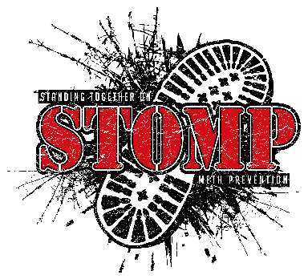
Jack County STOMP
505 W. Belknap St
P.O Box 425
Jacksboro, Tx
(940)507-5110
www.jackcountystomp.org

